PRODUCT REQUEST FORM
PRODUCT NAME: | Plastic Dropper Bottle
DESCRIPTION OF REQUEST:  - New Product  - Modification  - Product Extension  - Country addition  - Label Change  - Intended Use  -…Etc… | Plastic Dropper Bottle, a critical component for liquid handling and precise dosing in both the allergy immunotherapy and compounding pharmacy markets, addressing a clear need within our strategic verticals.  Project Background  The U.S. allergy immunotherapy market is experiencing robust growth, with a valuation of $9.49 billion in 2024 and a projected CAGR of 7.5% to reach $19.56 billion by 2034. A key driver of this growth is the increasing adoption of Sublingual Immunotherapy (SLIT), favored for its convenience and home-based administration. Within the consumables segment (valued at $2.8-$3.5 billion), precise and reliable allergen extract delivery is paramount for both treatment efficacy and patient safety.  Plastic Bottles with Dropper Tips are essential for:  - Allergy Clinics (SLIT): Serving as the primary container and dispenser for sublingual immunotherapy (SLIT) allergen extracts, requiring precise, patient-administered dosing.  - Compounding Pharmacies: Used in formulating ophthalmology medications, pediatric solutions, and other sterile/non-sterile liquid preparations where controlled droplet administration is critical.  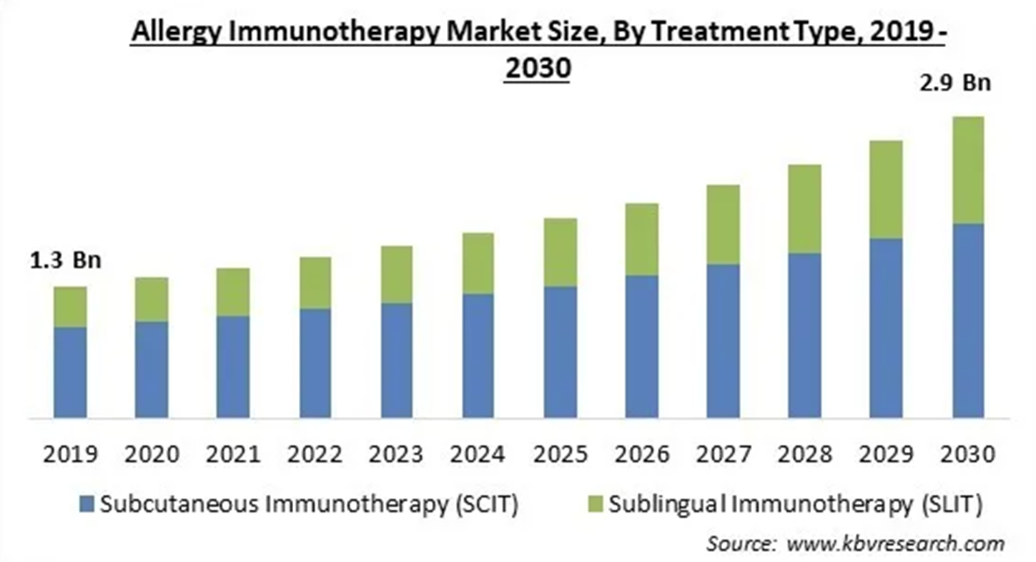
PURPOSE OF REQUEST: | ☐Complaint No. ☐Supplier ☒New market_______US_________  ☐Customer ___ ☐Internal _ ☐Other________________________  Add details:
ESTIMATED BENEFITS: | ☒ Financial Benefit: Complete the product lines for the allergy clinics markets, Annual sales amount $ 450K (Mandatory For NPD request)  Estimate the potential increase in cash flows, revenues, or any other financial benefits  ☐ Cost Saving:__________  Decrease in the cogs, transportation or operation expenses, or any other cost-saving opportunities  ☐ Improved Operational Efficiencies:_________  Decrease in the Lead time, delivery time, MOQ, Inventory, or any other efficiency improvement  ☐ Non-Financial Benefits:_________  Quality Improvement; Enhanced customer satisfaction, product competition, Brand reputation, etc.  ☐ Other Benefits:__________
PRODUCT DESCRIPTION:  - Functional performance requirements  - Appearance  - Any unique points of differentiation against similar competitor product lines  . ..Etc… | 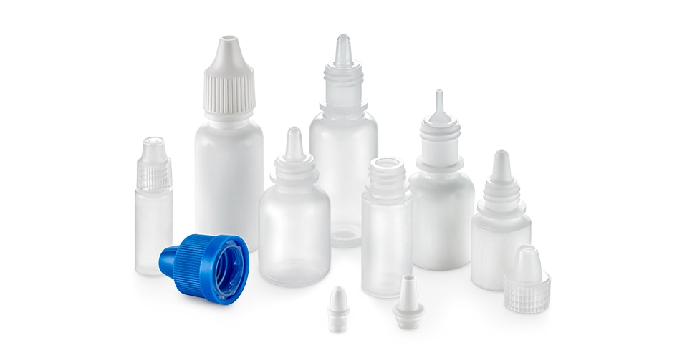  Product: Multi-dose, squeezable plastic bottles with attached, calibrated dropper tips.  Primary Use: For the storage, dispensing, and administration of liquid medications (e.g., SLIT drops, ophthalmic solutions) in clinical and pharmacy settings.  Key Sourcing Specifications: We will target partners capable of providing:  - Material Compliance: Medical-grade plastics compatible with a wide range of pharmaceutical formulations.  - Dosing Consistency: Dropper tips designed to deliver a consistent volume per drop.  - Regulatory Support: Manufactured in a cGMP environment, with supporting documentation suitable for use in regulated compounding (USP <795>/<797>).
REQUEST TYPE | ☐LCR (Labelling Change Request)  Changes on the labels without changing the products  ☐SCR (Supplier Change Request)  Change applications initiated by Suppliers  ☐ECR (Engineering Change Request)  Existing products that SOLM is the legal manufacturer  Engineer changes that are not bringing new hazards/risks  ☐NPD (New Product Development)  Develop new innovative products that SOLM will be the legal manufacturer  Significant changes on existing products that may bring new hazards/risks or new intended use  Change products from outsourcing to SOLM to be the legal manufacturer  Development of VET/Component products  ☐SDP (SOLM Distributor Product)  New product introduction that SOLM will not be the legal manufacturer  No change on the product, no SOLM information on the labels  ☒SPP (SOLM Portfolio Product)  New product introduction that SOLM will not be the legal manufacturer  No change on the product, Add SOLM information on the labels  ☐Customized Product / Market  Purchased products that SOLM is not the legal manufacturer  Engineering change on products or new customized products requested by SOLM  New Market region requested by SOLM
TARGET MARKET: | ☒ US ☐ Canada ☐ EMEA ☐ UK ☐ Brazil ☐ Australia & New Zealand ☐ Other countries/regions, list:
TARGET USE: | ☒ Human Use  ☐ Animal Health | STERILE | ☐ YES  ☒ NO
VOLUME/SALES OPPORTUNITY: | Launch volume required: | Yr 1 estimate | Yr 2 estimate
CUSTOMER NOTIFICATION | Do we have any special quality agreement in place with customer which requires approval before implementing changes? ☐ YES ☒ NO  If Yes, please provide the customer's name and evidence.  Attach the customer confirmation GF-0083 at the end of the form.  Is notification to the customers needed after change project is closed? ☐ YES ☒ NO  Remark:  Example: change affect regulatory, performance, appearance, etc. Notification method.
LEGAL MANUFACTURER: | ☐ Sol-Millennium  ☒ Other: __________ | BRANDING | ☒ Sol-Millennium  ☐ Private Label
EXPECTED PRODUCT LAUNCH PERIOD: | ☒ < 1 year  ☐ 1-3 year  ☐ > 3 years | EXPECTED PRODUCT LIFE PERIOD: | 10 years
NAME AND DATE of REQUEST: | Alex Lu 2026/1/29
Business Case & Commercial Rationale
This project targets a high-value, recurrent-purchase item with significant strategic and financial upside.
Product | COO | Den Uni Price | Target Uni Price | Target Gross Margin | Annual consumption in US | Solm采购量（10% ） | Est. Sale Revenue
7/10 mL Plastic Cap | China
7.5mL Natural Plastic Bottle | China |  | 1.5 | 60% | 3,000,000 | 300,000 | 450,000
10mL Natural Plastic Bottle | China
15mL Natural Plastic Bottle | China
40uL Metered Dose  Dropper Tip | China

